CITY OF CHILLIWACK

NOTICE OF PUBLIC HEARING
Tuesday, December 3, 2019 at 7:00 p.m.
Council Chambers
8550 Young Road, Chilliwack, BC V2P 8A4
www.chilliwack.com

TAKE NOTICE that the Council of the City of Chilliwack will hold a Public Hearing, as noted above, on the following items:

- OFFICIAL COMMUNITY PLAN BYLAW AMENDMENT BYLAW 2019, No. 4762 (RZ001307)
- OFFICIAL COMMUNITY PLAN BYLAW AMENDMENT BYLAW 2019, No. 4763 (RZ001307)
- ZONING BYLAW AMENDMENT BYLAW 2019, No. 4764 (RZ001307)
- DEVELOPMENT VARIANCE PERMIT (DVP01089)
Location: 45530 Vedder Mountain Road (portions of)
Applicant: CHP Architects
Purposes: To amend the Official Community Plan Development Permit Area Map 6 “DPA – Map 6”, to include the subject property, and to amend the Official Community Plan designation of a portion of the property located at 45530 Vedder Mountain Road from "Vedder River Management Area" to "General Commercial”. The proposal is also to rezone a portion of the subject property from a CS2 (Tourist Commercial) Zone to a C5 (Night Club/ Neighbourhood Pub) Zone and an RSV1 (Limited Use Reserve) Zone, as shown on the map below.
The following variances are being requested to the standards of the proposed C5 (Night Club/Neighbourhood Pub) Zone and the existing CS2 (Tourist Commercial) Zone, to facilitate the construction of a new commercial development, as shown on the map below:
- to reduce the total required number of off-street parking spaces for the development from 124 to 93 spaces; and,
- to reduce the required front lot line setback from 10m (as per the proposed C5 Zone) to 4.4m.
Location Map

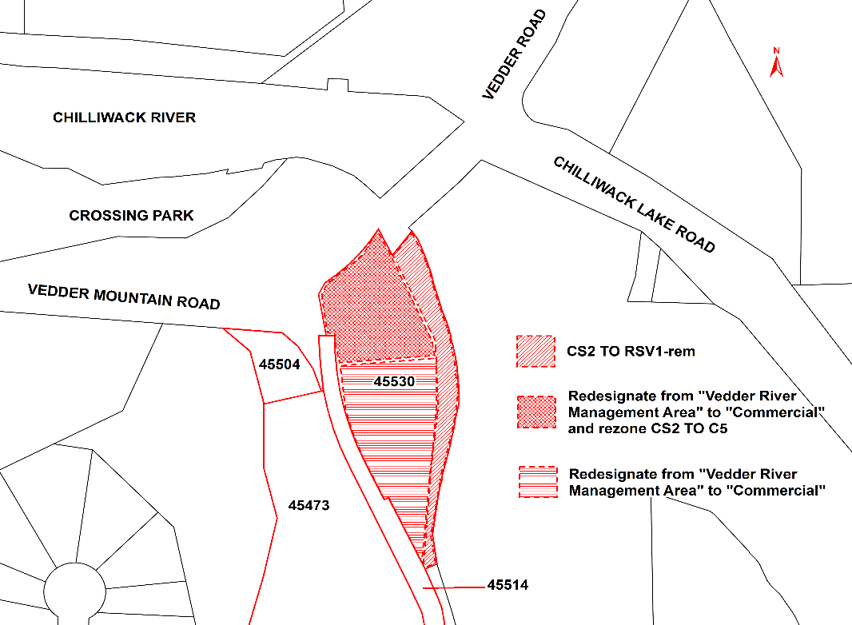

Persons who deem that their interest in the property is affected by the proposed amendment bylaws will have an opportunity to be heard at the Public Hearing or, if you are unable to attend, you may provide a written submission, including your full name and address, to the Corporate Services Department at 8550 Young Road, Chilliwack, BC, V2P 8A4 or by email to clerks@chilliwack.com no later than 4:00 p.m. on the date of the Public Hearing. All submissions will be recorded and form part of the official record of the Hearing.

These proposed bylaws may be inspected between the hours of 8:30 am and 4:30 pm, Monday through Friday, excluding holidays, from Wednesday, November 20, 2019 to Tuesday, December 3, 2019, both inclusive, in the Corporate Services Department at City Hall, 8550 Young Road, Chilliwack, BC. Please direct your enquiries to our Planning & Strategic Initiatives Department at 604-793-2906.

Please note that no further information or submissions can be considered by Council after the conclusion of the Public Hearing.

Jacqueline Morgan, CMC
Corporate Office

